1. What is the command to invoke the slack-request function (4 pts)?
   1. Via Curl
   2. Via faas-cli

# Answer -

1. Via Curl - curl localhost:8080/function/slack-request -d {}
2. Via faas-cli - faas-cli invoke slack-request
3. What is the output you see when you invoke the slack-request function? (2 pts)

# Answer -

Output of the slack-request function invocation -

```

{"text": "Serverless Message", "attachments": [{"fields": [{"short": true,

"value": "100", "title": "Amazing Level"}], "author_icon": "https://github.com/almasaslamkhan/cloudcomputing/tree/main/hw2", "image_url": "https://hub.docker.com/repository/docker/almasaslam/slack-request", "author_name": "Almas Aslam", "title": "The Awesome world of Cloud Computing! COEN 241"}, {"text": "COEN 241 is the most awesome class ever!.", "title": "About COEN 241"}, {"title": "Would you recommend COEN

241 to your friends?", "color": "#3AA3E3", "actions": [{"text": "Of Course!", "type": "button", "name": "recommend", "value": "recommend"},

{"text": "Most Definitely!", "type": "button", "name": "definitely", "value": "definitely"}], "callback_id": "response123", "fallback": "Would you recommend COEN 241 to your friends?", "attachment_type": "default"}]}

```

Below is the screenshot showing the invocation of `slack-request` function using two ways:

1. Curl 2. faas-cli -

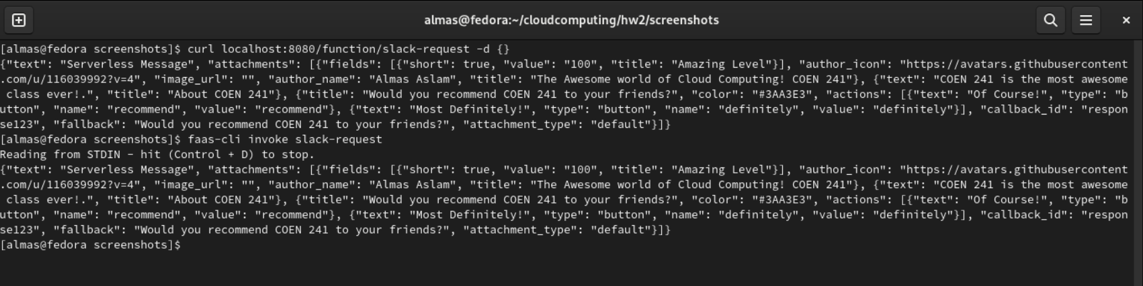

1. What is the command to invoke the slack-interactive function? (4 pts)
   1. Via curl
   2. Via faas-cli

# Answer -

1. Via Curl - curl localhost:8080/function/slack-interactive -d {}
2. Via faas-cli - faas-cli invoke slack-interactive
3. What is the output you see when you invoke the slack-interactive function? (2 pts)

# Answer -

```

{"attachments": [{"footer": "Slack Apps built on OpenFaas", "author_link": "https://github.com/almasaslamkhan/cloudcomputing/tree/main/hw2", "color": "#36a64f", "text": "Head over to COEN 241", "title": "COEN 241", "ts": 123456789, "author_name": "Almas Aslam", "title_link": "https://[www.scu.edu/engineering/academic-programs/department-of-computer-e](http://www.scu.edu/engineering/academic-programs/department-of-computer-e) ngineering/graduate/course-descriptions/", "image_url": "https://[www.scu.edu/media/offices/umc/scu-brand-guidelines/visual-identity](http://www.scu.edu/media/offices/umc/scu-brand-guidelines/visual-identity)

-amp-photography/visual-identity-toolkit/logos-amp-seals/Mission-Dont3.png"

, "response_type": "ephemeral", "replace_original": true, "footer_icon": "https://a.slack-edge.com/45901/marketing/img/_rebrand/meta/slack_hash_256. png", "pretext": "Ahh yeah! Great choice, COEN 241 is absolutely amazing!", "fallback": "Required plain-text summary of the attachment.", "thumb_url": "https://[www.scu.edu/engineering/academic-programs/department-of-computer-e](http://www.scu.edu/engineering/academic-programs/department-of-computer-e) ngineering/graduate/course-descriptions/", "author_icon": "https://github.com/panu2306"}]}

```

1. How would you pass different arguments to the functions? (4 pts)

# Answer -

We can pass either text or JSON to the arguments of the functions. We can further alter the JSON payload as an argument to the function. By making changes into the json file, we can alter the request to the function and based on the request, we can make changes into the handler function to process the textual or json request. Further, we can even change the content-type in the yaml file if we want to send arguments like “plain text” to the handler files instead of JSON.

1. How would you change the slack-interactive function to react to different inputs? (4 pts)

# Answer -

The slack-interactive function uses `handler.py` file code to accept the request in the format of text or json. In handler.py, we have defined an unquote function which is part of a package called urllib which can be used to decode any string into a URL. The default encoding is UTF-8. After that, we utilize the json.load() method to transform a valid JSON string, such as urlstring, into a python dictionary whose information is saved in the response. After storing it in the response, we see it is not getting used anywhere. We can update the slack-interactive function to react to different inputs. Response can be utilized inside the data because it is also a Python dictionary. As a result, when we return json.dumps(data), the function will begin to react to various inputs. Moreover, we can use different slack objects like buttons, checkboxes, links in the form of JSON code to create various interactive options in the slack bot responses.